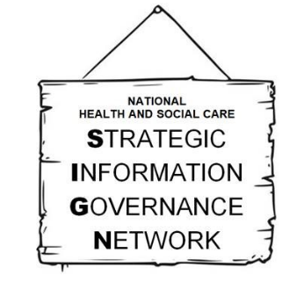
INFORMATION
GOVERNANCE
AWARDS 2021
NOMINATION FORM

Please note:
- Nominations for the Awards can only be made using this form, which must be emailed to UHSussex.InformationGovernanceAwards@nhs.net. Nominations will not be accepted by any other route or media.
- If any field of the form is incomplete, the nomination will be deemed invalid and notified to the nominator.
- A new form must be completed for each person / Team nominated, and for each category.
- Any text in excess of 300 words will be discounted when shared with the Judging Panel.
- At judging stage the Judging Panel receive a redacted version of the nomination with, wherever possible, nominee names, gender and, organisations removed. Other identifiers may unavoidably remain.
- With regard to the Information Governance Team of the Year Award only, give the Team Lead’s details in Q1-5, and the other Team members’ names in Q8.
- Nominations close at midnight on 30 September 2021, and will under no circumstances be accepted after then.
- If the nominee requests details of who nominated them, permission will generally be sought of the nominator ahead of this information being released.

Details of nominee:
- Full name
- Job title
- Employer
- Phone number
- Email
- Nomination category | Select ONE category only | Tick
- Nomination category | Information Governance Professional of the Year
- Nomination category | Information Sharing Champion of the Year
- Nomination category | Information Governance Innovator of the Year
- Nomination category | Information Governance Team of the Year
- Nomination category | Information Governance Human Encyclopædia
- Nomination category | Outstanding Contribution to Information Governance
- Nomination category | Special Recognition for Supporting the Covid-19 Effort with Information Governance
- Supporting statement (upto 300 words)
- Team members (for the Information Governance Team of the Year Award ONLY)

Details of nominator:
- Full name
- Job title
- Employer
- Phone number
- Email

